**Lab 1**

You need to know at least one programming language to perform reasonably well on certain exam questions.

**Question 1**: Review the following method and find (at least) 5 issues in the code (i.e., coding practice, compile errors, potential logical issues, etc.)

(using template 1)

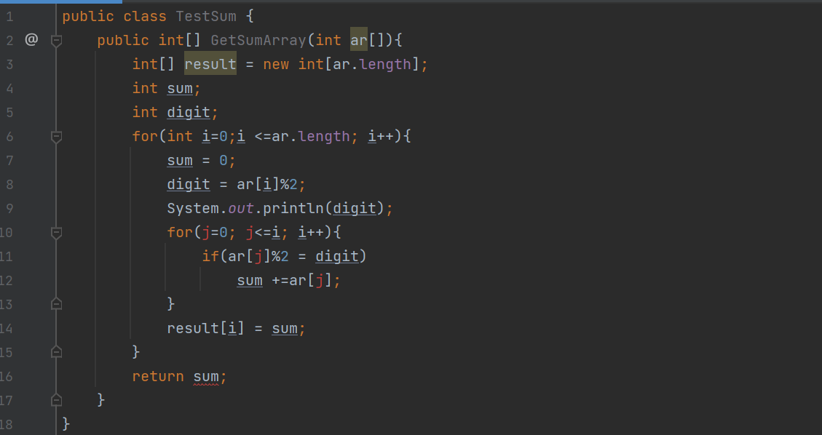

**Question 2**: Create a project, using maven template.

Apply unit test for user authentication.

* Create an UserAuth class:
  + with 3 members: username, password, status
  + Methods: checklogin, to allow user login with valid username, and password, and status.
* Create some methods to test the user authentication using parameterized or csv file.